**TSDS Field Coordinator Network Q&A**

**Tuesday, December 10, 2024, 9:00 AM CT**

**TSDS Submission Updates:**

PEIMS Reports:

The following report was updated to correct the calculation for counting Hispanic/Latino students. This update was included in software release on December 6, 2024, but was not included in the Release Notes.

* PDM1-120-001 Student Type by Grade, Ethnicity and Sex

RF Tracker:

* The RF Tracker data checkpoint deadline has been **extended to Friday, January 17, 2025**.​
* Promotion Known Issue:
  + When promoting the StudentResidentialFacility and the RF Exit Date is null, the date may promote as ‘01/01/2099’.
  + This issue will be resolved this week.​ Stay tuned for further information.

ECDS:

|  |  |  |
| --- | --- | --- |
| ECDS Assessment Vendor  Kindergarten | Assessment(s) | IODS Load Schedule​ |
| Children’s Learning Institute (CLI) | BOY KG TX-KEA English​ ​  BOY KG TX-KEA Spanish | Each LEA will perform their first data publication to the IODS.​ ​  Districts can choose  **on-demand or real-time** publication to their IODS. |
| Amplify | BOY KG mCLASS TX Assessment​ ​  BOY KG mCLASS TX Lectura Assessment Espanol | This will begin when the district establishes their IODS integration.​ ​  **Twice daily at 8:00 a.m. & 2:00 p.m. CST** |

|  |  |  |
| --- | --- | --- |
| ECDS Assessment Vendor  Prekindergarten | Assessments(s) | IODS Load Schedule​ |
| Children’s Learning Institute (CLI) | BOY/EOY PK CIRCLE CLI English  BOY/EOY PK CIRCLE CLI Spanish | Each LEA will perform their first data publication to the IODS.​ ​  Districts can choose​  **on-demand or real-time** publication to their IODS. |
| Teaching Strategies | BOY/EOY PK GOLD English  BOY/EOY PK GOLD Spanish | Districts can submit​  **on-demand** publication to their IODS. |
| FrogStreet | BOY/EOY PK Frog Street Assessment English  BOY/EOY PK Frog Street Assessment Spanish | Once configured by the LEA, Frog Street will publish data **nightly** to the IODS around **6:00 p.m.** |
| HighScope/Kaymbu | BOY/EOY PK COR Advantage English  BOY/EOY PK COR Advantage Spanish | Kaymbu publishes data to the IODS **every morning** at **3 a.m.** and includes the last 24 hours of assessment scores collected. |
| Liberty Source/ Tango | BOY/EOY PK CPALLS+STEM English  BOY/EOY PK CPALLS+STEM Spanish  BOY/EOY PK LION for Prekindergarten English  BOY/EOY PK LION for Prekindergarten Spanish | Districts can submit​  **on-demand** publication to their IODS. |

**TEDS:**

* Economic Disadvantage Guidance Changes

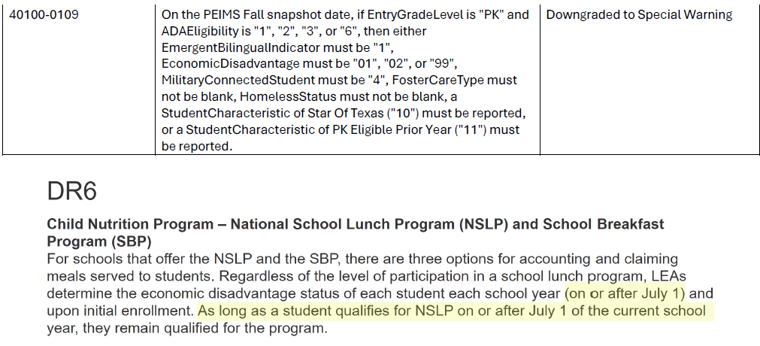









**Support:**

**Do:**

* Utilize the TSDS TIMS Support portal to view tickets submitted by your LEAs.
* Submit a ticket for requests or issues specific to your region.
* Provide a clear description of the request and/or issue.
* Attach supporting documents and/or screenshots when possible. The more troubleshooting and documentation you provide, the faster our team can work to resolve or escalate the issue for you.
* Identify the severity of the issue based upon LEA/ESC impact and submission.
* Use the DMC > Search Data and PEIMS > Search Submission Data feature to verify what has been reported when troubleshooting a rule. *Current* data must be promoted in order to be able to resolve a *current* issue.

**Do not:**

* Have your LEAs submit a TIMS ticket for vendor specific/known issues or for TEA known issues. Reference TSDSKB-600 for TEA known issues and the FCN Newsletters under the “Helpful Links” button on the TIMS Support Portal.
* Create duplicate tickets for the same issue. Please check the ticket portal first to ensure that there is not a ticket already created.
* Combine multiple complex issues within one support ticket.
* Forget to confirm resolved issues when the ticket is sent back.

**Training Team:**

* [TSDS Upgrade Champions Training materials](https://www.texasstudentdatasystem.org/tsds/about/training-and-support/tsds-training-materials):
  + [JSON Resource Document](http://tea4avcastro.tea.state.tx.us/tsds_training/TSDSUpgradeProject2024/ResourceDocuments/JSON_Resource_Document.pdf)
  + [Domain Dependency Resource Document](http://tea4avcastro.tea.state.tx.us/tsds_training/TSDSUpgradeProject2024/ResourceDocuments/Domain_%20Dependency_%20Resource_%20Document.pdf)
  + [Promotion Logic Resource Document](http://tea4avcastro.tea.state.tx.us/tsds_training/TSDSUpgradeProject2024/ResourceDocuments/Promotion_Logic_Resource_Document.pdf)

**Important Dates:**

* FCN Webinars - Tuesdays @ 9:00 a.m.
  + 12/17 (ad hoc)
  + 1/7/2025 (standard)
* [Click here to Register](https://zoom.us/webinar/register/WN_AYnEOb3WRgOy2-t3B7AC8A)